

NovaSensor
Upgrade Guide

Version: NovaSensor 3.0.37C
Released On: 2022-06-30

ForeNova Inc

Copyright Notice
Copyright © ForeNova Inc. 2022. All rights reserved, including but not limited to the rights of revision and final interpretation of this document.
Unless otherwise stated or authorized, ForeNova Inc. (hereinafter referred to as "ForeNova") and its affiliates reserve all intellectual property rights, including but not limited to copyrights, trademarks, patents, and trade secrets, and related rights to text, images, pictures, photographs, audio, videos, charts, colors, and layouts as presented in or concerning this document and content therein. Without the prior written consent of ForeNova, this document and content therein must not be reproduced, forwarded, adapted, modified or displayed or distributed by any other means for any purpose.
Special Notice
Products, services or features described in this document, whether wholly or in part, may not be within your purchase scope or usage scope. The products, services or features you purchase must be subject to the commercial contract and terms as agreed by you and ForeNova. Unless otherwise provided in the contract, ForeNova disclaims warranties of any kind, either express or implied, for the content of this document.
Due to product version upgrades or other reasons, the content of this document is subject to change from time to time without prior notification. Unless otherwise agreed, this document is used for reference only, and all statements, information, and recommendations therein do not constitute any express or implied warranties. ForeNova shall not be liable or responsible for any loss, liability or damage that you may incur due to modifications to or omissions or mistakes in this document.

Contact Us
Email: support@forenova.com
Official Website: www.forenova.com

Revision History
The revision history includes each document update. The latest document version contains updates from all previous document versions.
Date | Version | Description
2022-06-30 | 01 | This is the first release of this document.

Note Icons

Icon | Description
 | Indicates an imminently hazardous situation which, if not avoided, will result in death or serious injury.
 | Indicates a potentially hazardous situation which, if not avoided, could result in death or serious injury.
 | Indicates a hazardous situation, which if not avoided, could result in minor or moderate injury.
 | Indicates a hazardous situation, which if not avoided, could result in settings failing to take effect, equipment damage, or data loss.  NOTICE addresses practices not related to personal injury.
 | Calls attention to important information, best practices, and tips.  NOTE addresses information not related to personal injury or equipment damage.

Content
1. Overview 1
1.1 About This Version 1
1.1.1. What Is New 1
1.2. Upgrade Impacts 1
1.2.1. Impacts on Business 1
1.2.2. Impacts on O&M 1
1.2.3. Impacts on Network 1
1.2.4. Notes 1
1.3. Upgrade Process 2
2. Upgrade Guide 3
2.1 Preparation for Upgrade 3
2.1.1. Upgrade Tools 3
2.1.2 Environment Information 3
2.1.3 Customer Resource Coordination 3
2.2 Pre-Upgrade Check 3
2.3 Upgrade Procedures 4
2.3.1 Upgrade Paths 4
2.3.2 Upgrade Procedures 4
2.4 Post-Upgrade Check 5
2.4.1 Platform Check 5
2.4.2 Function Verification 5
2.5 Troubleshooting Upgrade Failures 6
2.6 Rollback Instructions 6

- Overview

1.1 About This Version
    - What Is New
New: MongoDB protocol audit detection
Add the function of auditing logs of MongoDB traffic, and uploading logs to NovaCommand for security detection and analysis.

New: protocol audit whitelist
Add protocol audit whitelists to enable users to configure the IP address, port and protocol of whitelisted traffic.

New: New Connection Method Between NovaSensor and NovaCommand
Enhance connection security between NovaSensor and NovaCommand.
  - Upgrade Impacts
1. The device will be restarted.
2. Deployment in bypass mode will only have impacts on NovaSensor and will not affect customer business. The upgrade will take about 25 minutes.
    - Impacts on Business
None
    - Impacts on O&M
The upgrade will take about 25 minutes.
    - Impacts on Network
Deployment in bypass mode will have no impacts on network.
    - Notes
None
  - Upgrade Process
See section 2.4.2.
- Upgrade Guide

2.1 Preparation for Upgrade
    - Upgrade Tools
- Upgrade Tools
Upgrade Tool | Description
License/Authorization change | Go to System > Licensing to check whether the software update license is still valid. If the license has expired, please renew the license.
Upgrade package | - Prepare the .ssu package of NS3.0.37C and check MD5.

2.1.2 Environment Information
- Device Info
Device Name | IP Address | Version | Username/Password
NS1 | 192.0.0.0 | NS3.0.30C | Admin/*******

2.1.3 Customer Resource Coordination
N/A

2.2 Pre-Upgrade Check
Update Limitations
Refer to the chapter Upgrade Impacts.
Graceful Upgrade of Configurations, Logs, and Data
Supported
SC/Central Manager
SC: Not supported
Central Manager: Not supported
HA/Multi Nodes/Cluster/Distributed Nodes
HA, cluster, and the primary-branch platform mode are not supported.

2.3 Upgrade Procedures

2.3.1 Upgrade Paths
Current Version | Upgrade Path | Notes
NovaSensor 3.0.30C | NovaSensor 3.0.30CNovaSensor 3.0.37C | During upgrade, the device will be restarted for about 25 minutes.

2.3.2 Upgrade Procedures
- Upgrade from NovaSensor 3.0.30C
Prerequisites
Check whether the .ssu package is complete and verify the MD5.

Step 1: Check that the version of the device to be updated is NovaSensor 3.0.30C.
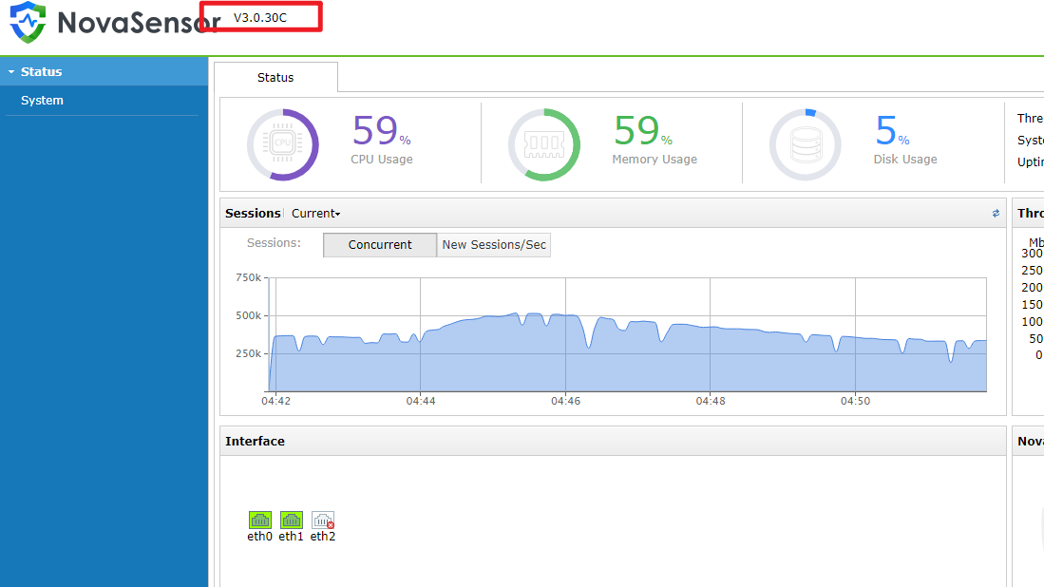
Step 2: On the NovaSensor, go to System > NovaCommand to write your NovaCommand IP address.
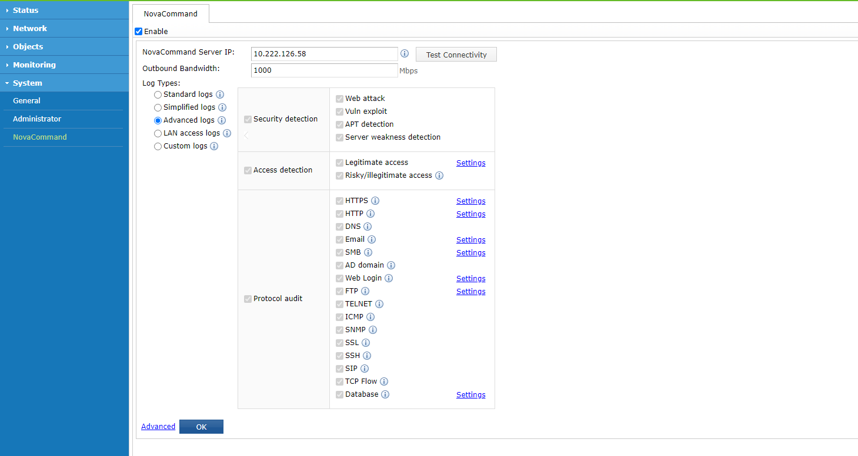
Step 3: On NovaCommand, go to System > Update > System Update > NovaSensor Update to import the .ssu package.
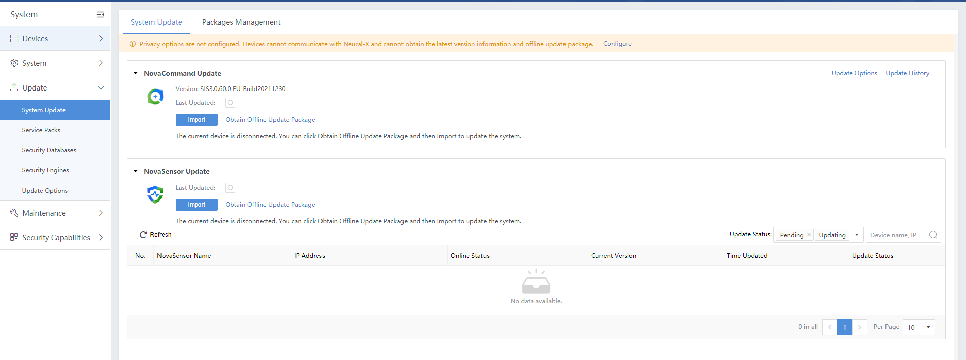

2.4 Post-Upgrade Check

2.4.1 Platform Check
You can see that the version number in the upper left corner of the UI page has changed to NovaSensor 3.0.37C.
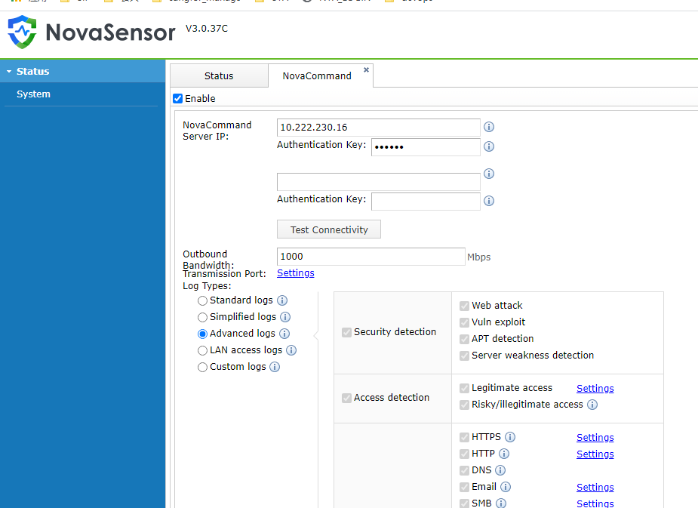

2.4.2 Function Verification
Log in to NovaCommand and go to the Logs page to check whether there are new logs synchronized from NovaSensor.
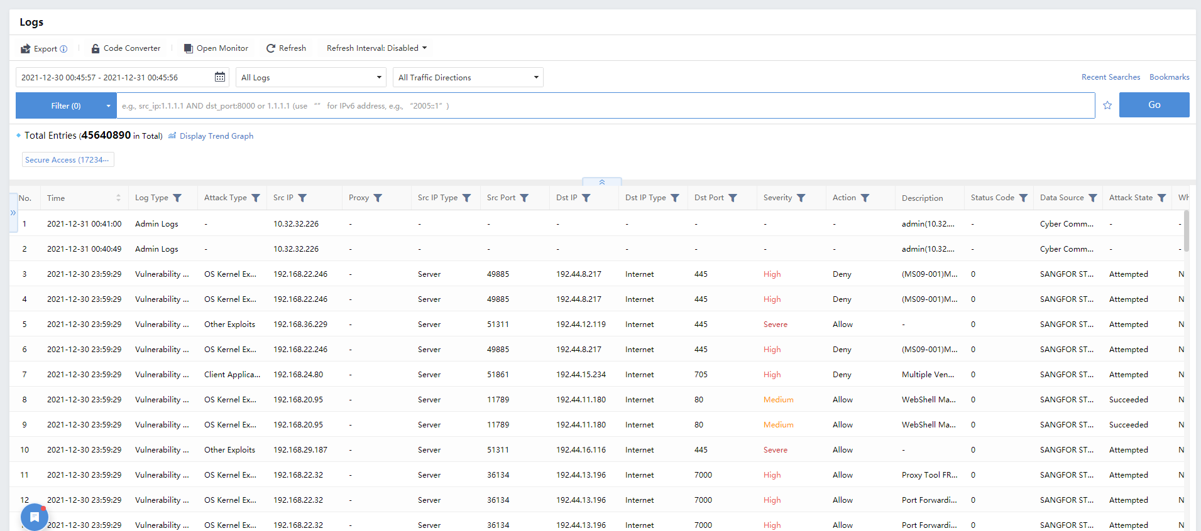

2.5 Troubleshooting Upgrade Failures
Scenario 1: Upgrade failed
Troubleshooting:
1. Check whether .ssu package is complete and verify MD5.
2. Check whether upgrade is supported for the version.
3. Check whether the upgrade license is valid.
4. Log in to the backend to check whether there are error messages or anomalies from /var/log/ssu_update.log. If yes, contact R&D.

2.6 Rollback Instructions
None

