NovaSensor 3.0.37C

Release Notes



Drafted By | Xie Junjie | Date | 2022-06-30
Reviewed By |  | Date

Content

1. Version Benefits 3
2. Version 3
3. Version Features 4
4. Feature Details 4
4.1. MongoDB Protocol Audit 4
4.1.1. Benefits 4
4.1.2. Scenarios 4
4.1.3. Target Users 4
4.1.4. UI 4
4.1.5. Pending Issues and Notes 5
4.1.6. Troubleshooting 5
4.2. Protocol Audit Whitelist 6
4.2.1. Benefits 6
4.2.2. Scenarios 6
4.2.3. Target Users 6
4.2.4. UI 6
4.2.5. Pending Issues and Notes 8
4.2.6. Troubleshooting 8
4.3. New Connection Method Between NovaSensor and NovaCommand 9
4.3.1. Benefits 9
4.3.2. Scenarios 9
4.3.3. Target Users 9
4.3.4. UI 9
4.3.5. Pending Issues and Notes 10
4.3.6. Troubleshooting 10
5. Issues Fixed 11
6. Software List 11
7. Contact Us 11

Version Benefits
NovaSensor 3.0.37C has added the following functions: MongoDB protocol audit, protocol audit whitelist, NovaSensor connection method.

Version
Version | NovaSensor3.0.37C
Released On | June 30, 2022
Project Owner | Xie Junjie
Reviewed By
Release Notes | See section 3

Version Features
No. | Description
1 | New: MongoDB protocol audit
2 | New: protocol audit whitelist
3 | New: connection method between NovaSensor and NovaCommand

Feature Details

MongoDB Protocol Audit

Benefits
1. Add MongoDB Wire Protocol audit to enhance NovaSensor's protocol audit capability.

Scenarios
All

Target Users
O&M personnel

UI

- Go to System > Nova Command to enable or disable MongoDB audit.
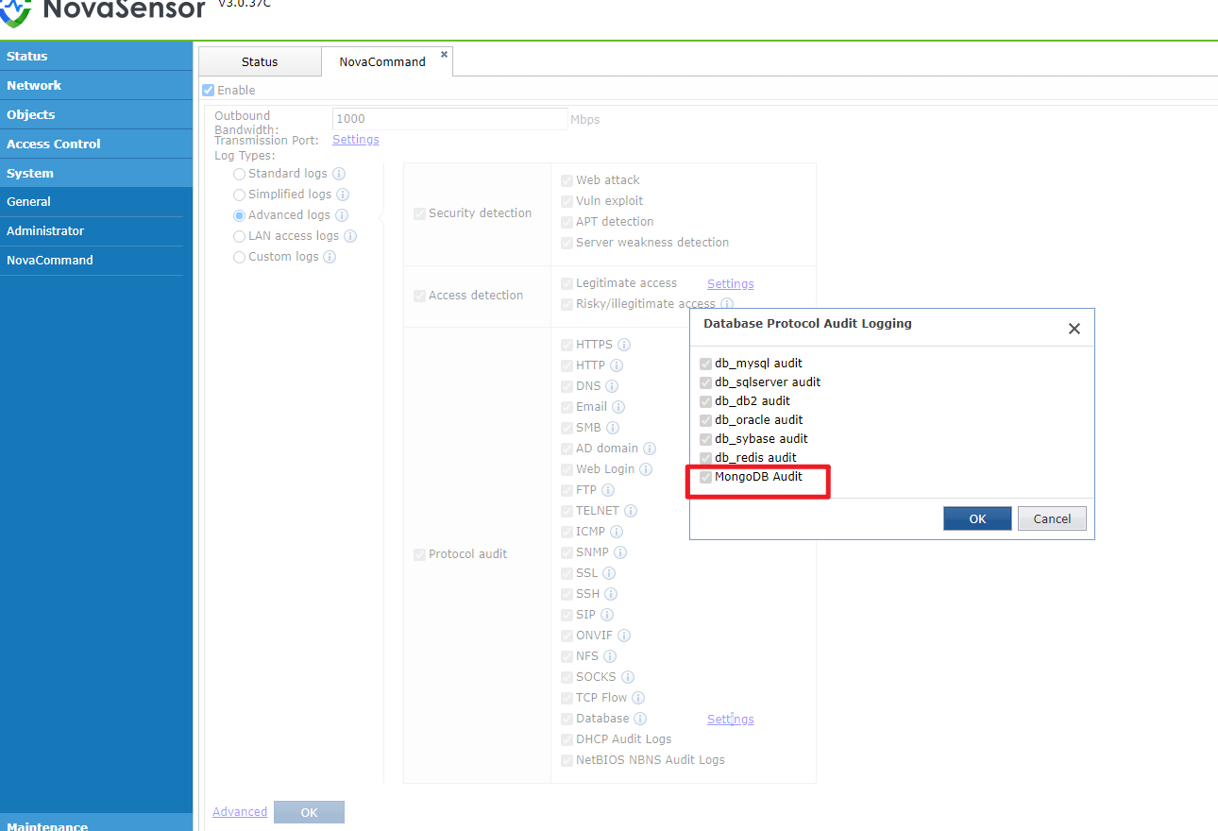

Pending Issues and Notes
None

Troubleshooting
None

Protocol Audit Whitelist

Benefits
1. You can select multiple or all threat types in one security whitelist entry, allowing to configure fewer whitelist entries. You can add up to 1000 security whitelist entries.
2. You can configure up to 500 audit whitelist entries now. The audit whitelist will take place on NovaSensor instead of NovaCommand. You can push down audit whitelists to NovaSensor. The traffic will be whitelisted on NovaSensor, avoiding generating security logs, alerts, and incidents when no audit logs are generated for whitelisted traffic.

Scenarios
All

Target Users
Security admin, O&M personnel

UI
1. Go to System > Security Capabilities > Whitelists to configure audit whitelists so that audit logs of corresponding protocol will not be audited.
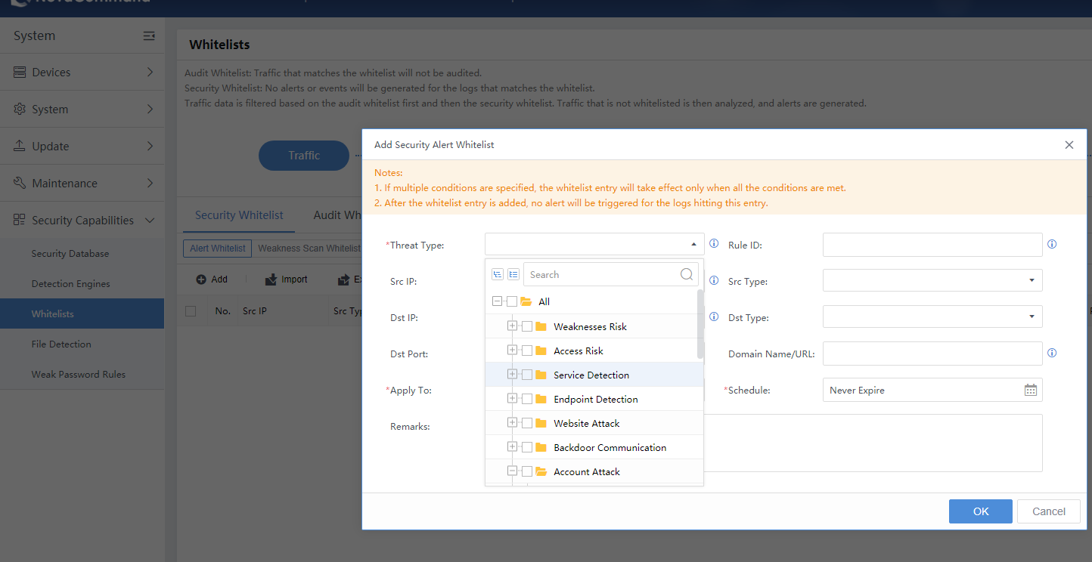

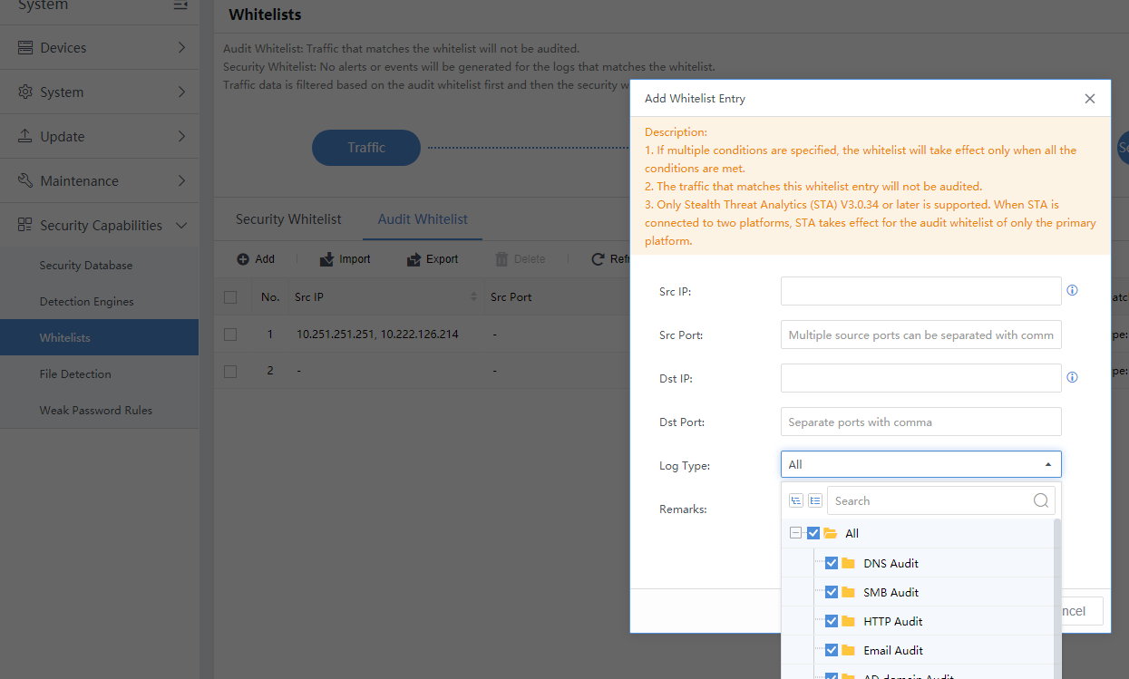
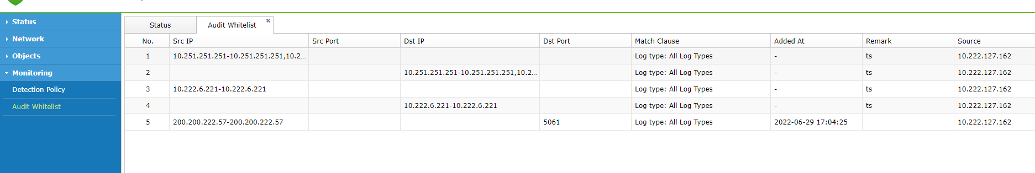
2. Configure audit whitelists only based on the source or destination addresses, source or destination port, or log type.

Pending Issues and Notes
None

Troubleshooting
None

New Connection Method Between NovaSensor and NovaCommand

Benefits
Optimize the connection method between NovaSensor and NovaCommand by using AKSK, to make their communication more secure

Scenarios
Operation and maintenance

Target Users
O&M personnel

UI
1. On NovaCommand, go to System > Devices > Sensor Devices to click NS Connection Configuration to generate connection key.
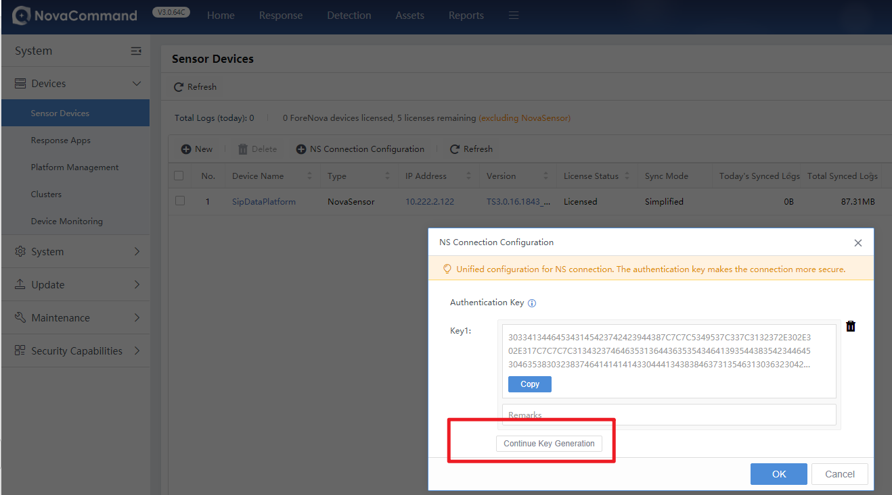

2. On NovaSensor, go to System > Nova Command to enter the IP address and authentication key of NovaCommand.
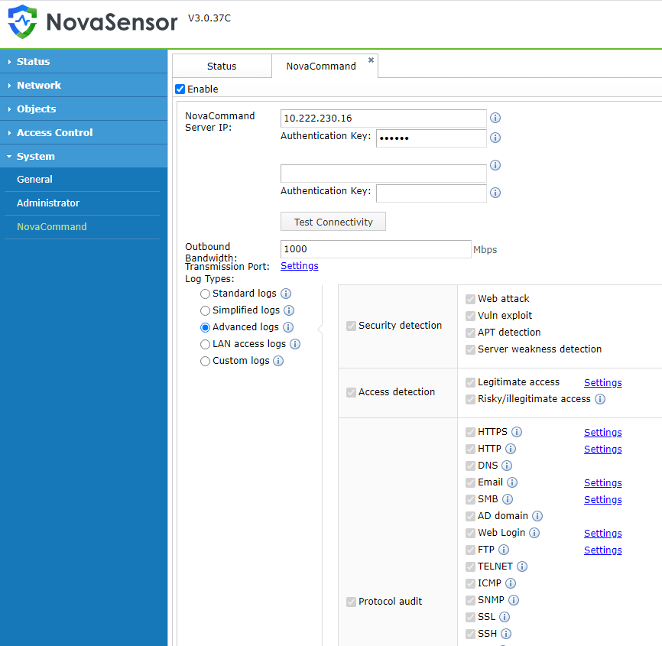

Pending Issues and Notes
- Multiple NovaSensor devices can use the same key or different keys.
- For NovaSensor devices that have been connected to a version earlier than Nova Command3.0.64, choose the connection method previously used for smooth upgrade.

Troubleshooting
None

Issues Fixed
None

Software List
Items | File | MD5
Software Installation Package | iso file | 637063A3756AA326A48AF7B7A204B59C
Database Upgrade Package | ssu file | 6F2434B5C6018C99EC49E277D722DD00
Upgrade & Delivery Guide
Compatibility List

Contact Us
Email: support@forenova.com
Official Website: www.forenova.com

