

ForeNova
Upgrade Guide

Product Version: NovaCommand3.0.64
Released On: 2022-06-30


ForeNova Inc

Copyright Notice
Copyright © ForeNova Inc. 2022. All rights reserved, including but not limited to the rights of revision and final interpretation of this document.
Unless otherwise stated or authorized, ForeNova Inc. (hereinafter referred to as "ForeNova") and its affiliates reserve all intellectual property rights, including but not limited to copyrights, trademarks, patents, and trade secrets, and related rights to text, images, pictures, photographs, audio, videos, charts, colors, and layouts as presented in or concerning this document and content therein. Without the prior written consent of ForeNova, this document and content therein must not be reproduced, forwarded, adapted, modified or displayed or distributed by any other means for any purpose.
Special Notice
Products, services or features described in this document, whether wholly or in part, may not be within your purchase scope or usage scope. The products, services or features you purchase must be subject to the commercial contract and terms as agreed by you and ForeNova. Unless otherwise provided in the contract, ForeNova disclaims warranties of any kind, either express or implied, for the content of this document.
Due to product version upgrades or other reasons, the content of this document is subject to change from time to time without prior notification. Unless otherwise agreed, this document is used for reference only, and all statements, information, and recommendations therein do not constitute any express or implied warranties. ForeNova shall not be liable or responsible for any loss, liability or damage that you may incur due to modifications to or omissions or mistakes in this document.
Contact Us
Email: support@forenova.com
Official Website: www.forenova.com

Revision History
The revision history includes each document update. The latest document version contains updates from all previous document versions.
Date | Version | Description
2022-06-30 | 01 | This is the first release of this document.

Note Icons
Icon | Description
 | Indicates an imminently hazardous situation which, if not avoided, will result in death or serious injury.
 | Indicates a potentially hazardous situation which, if not avoided, could result in death or serious injury.
 | Indicates a hazardous situation, which if not avoided, could result in minor or moderate injury.
 | Indicates a hazardous situation, which if not avoided, could result in settings failing to take effect, equipment damage, or data loss. NOTICE addresses practices not related to personal injury.
 | Calls attention to important information, best practices, and tips. NOTE addresses information not related to personal injury or equipment damage.

Content
1. Overview 1
1.1. About This Version 1
1.2. Upgrade Impacts 2
1.2.1. Impacts on Business 2
1.2.2. Impacts on O&M 2
1.2.3. Impacts on Network 3
1.2.4. Notes 3
1.3. Upgrade Process 3
2. Upgrade Guide 4
2.1. Preparation for Upgrade 4
2.1.1. Upgrade Tools 4
2.1.2. Environment Information 4
2.1.3. Customer Resource Coordination 4
2.2. Pre-Upgrade Check 4
2.3. Upgrade Procedures 5
2.3.1. Upgrade Paths 5
2.3.2. Upgrade Procedures 5
2.4. Post-Upgrade Check 5
2.4.1. Platform Check 5
2.4.2. Function Verification 6
3. Upgrade Methods 7
3.1. Upgrade from GUI 7
3.1.1. Upgrade Processes 7
3.1.2. Upgrade Procedures 7
4. Troubleshooting Upgrade Failures 9
5. Rollback Instructions 10

- Overview
  - About This Version
Enhanced: Alerts displayed by details or correlation
1. Allow to view alerts in two modes: by details, by correlation
2. Adjust the menu bar, search, filter, and statistical graph on the Response > Security Alerts.

Enhanced: Alert/Incident proof optimized
1. In the proof details, the diagram about the attacker and the target is optimized.
2. Allow to display threat information in a table not nested when multiple attackers are associated with multiple targets in Threats tab.
3. Security alarm/event correlation logic is optimized.
4. The styles are made consistent between the Log Details page and the Logs module.
5. Allow to click Go to Logs on the Original Logs tab to enter the Logs module.

New: Custom intelligence
1. Display rule detection engines and incident/alert detection engines in different submodules of Security Capabilities.
4. Pop up a message when you try to enable or disable an incident or alert detection engine in the Security Capability module.
3. Allow to generate custom incidents or alerts.
4. Allow to restore all policies about generating incidents or alerts to default.

Enhanced: Whitelist
1. Allow to import and export alert whitelists, vulnerability scan whitelist, and audit whitelist.
2. Push down audit whitelists to NovaSensor, reducing the audit workload of NovaSensor.
3. Allow to select all whitelists and configure whitelists more flexibly. For example, you can whitelist a kind of email address suffix like "*@google.com".

New: Cluster expansion
1. The maximum traffic that the current platform can support is limited. If large traffic needs to be used, you can expand the capacity by adding cluster nodes.

New: Netherlands can be selected as a customer location which also applies to the monitor
1. Netherlands can be selected as a customer location which also applies to the monitor.

New: Licensing management of third-party integrated devices
1. Allow to license third-party integrated devices based on quantity and validity period.

New: Threshold settings for the abnormal behavior engine
1. Allow to configure thresholds for scans and brute-force attacks detected by the abnormal behavior engine.

New: Audio alert
1. Add the audio alert function in Response > Security Alerts.
2. Allow to specify the alerts to give audio alert.

New: AKSK added to the connection method between NovaSensor and NovaCommand
1. Only NovaSensor 3.0.37C or later can be connected to the platform using AKSK.

New: Access control for source IP addresses
1. Allow to go to System > System > General > Web UI > Remote Control to set the IP addresses that can access the platform backend.

Enhanced: User experience
Fix issues to enhance user experience.

For feature details, please check SFRD-VAL-09-1.0_NC3.0.64C Release Notes.doc.

  - Upgrade Impacts
- The device will be restarted.
- Deployment in bypass mode will only have impacts on NovaCommand and will not affect customer business. The upgrade will take about 20 minutes.
- Since the data detection logic has been changed, data may be inaccurate within one or two weeks. Data may be unavailable on some pages such as the Detection module.
- System architecture has been changed a lot, which requires to upgrade security logs and events smoothly. After the device is upgraded successfully, you need to continuously perform a smooth upgrade for data. The platform can convert about 1 million old security events per hour. It is recommended to upgrade at night to spare enough time for smooth upgrade.
    - Impacts on Business
Deployment in bypass mode will only have impacts on NovaCommand and will not affect customer business.
    - Impacts on O&M
The upgrade will take about 20 minutes.
    - Impacts on Network
Deployment in bypass mode will have no impacts on network.
    - Notes
The URL used to log in to NovaCommand has been changed. If you have added the URL to your bookmark and want to log in with the bookmark again, you need to change the corresponding URL to the following format:
https://IP/ui/login/login.html
  - Upgrade Process
1. Prepare the .bin package of NovaCommand3.0.64C and check MD5.
2. Go to System > Update > System Update > NovaCommand Update to import .bin package. The upgrade will take about 20 minutes.

- Upgrade Guide
  - Preparation for Upgrade
    - Upgrade Tools
- Upgrade Tools
Upgrade Tool | Description
License/Authorization change | Go to System > Licensing to check whether the software update license is still valid. If the license has expired, please renew the license.
Upgrade package | - Prepare the .bin package of NovaCommand3.0.64C and check MD5.

    - Environment Information
- Device Info
Device Name | IP Address | Version | Username/Password
NC1 | 192.0.0.0 | NC3.0.60C | Admin/*******

    - Customer Resource Coordination
N/A
  - Pre-Upgrade Check
Update Limitations
Refer to the chapter Upgrade Impacts.
Graceful Upgrade of Configurations, Logs, and Data
Supported
SC/Central Manager
SC: Not supported
Central Manager: Not supported
HA/Multi Nodes/Cluster/Distributed Nodes
HA, cluster, and the primary-branch platform mode are not supported.

  - Upgrade Procedures
    - Upgrade Paths
Current Version | Upgrade Path | Notes
NovaCommand3.0.49C | NovaCommand3.0.49C NovaCommand3.0.60C NovaCommand3.0.64C | Device must be updated to NovaCommand3.0.60C first.
NovaCommand3.0.59C | NovaCommand3.0.59C NovaCommand3.0.60C NovaCommand3.0.64C | Device must be updated to NovaCommand3.0.60C first.
NovaCommand3.0.60C | NovaCommand3.0.60C NovaCommand3.0.64C
    - Upgrade Procedures
1. Back up user configuration, which will take about 1 to 3 minutes.
2. Prepare the .bin package of NovaCommand3.0.64C and check MD5.
3. Log in to the web console and go to System > Update > System Update > NovaCommand Update to import .bin package. Wait for the upgrade to be completed.
Wait for the upgrade to be completed.
  - Post-Upgrade Check
    - Platform Check
Log in to web console and go to System > Update > System Update > NovaCommand Update to check the version.
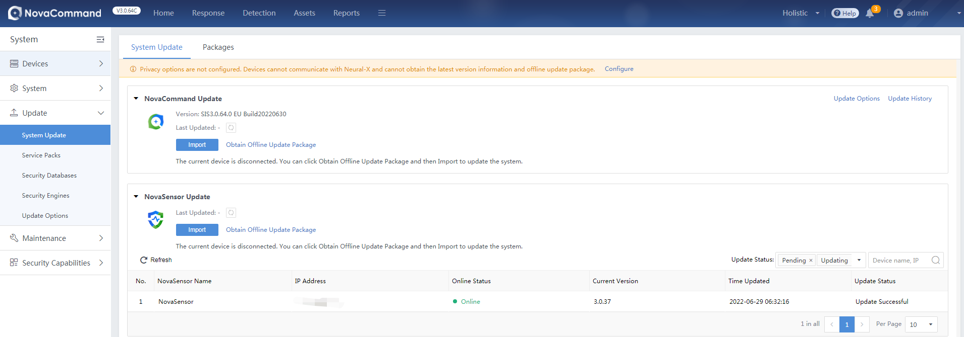

    - Function Verification
1. Verify basis functions used by customers.
2. Log in and go to the Logs page to check whether there are new logs synchronized from NovaSensor.
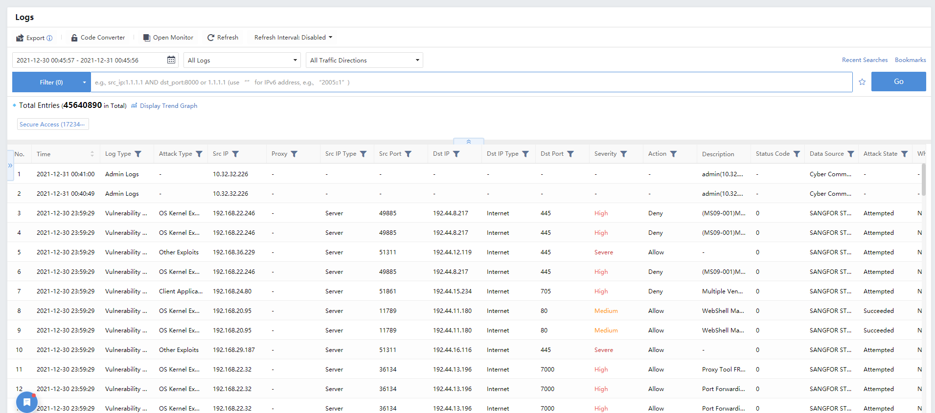

- Upgrade Methods
This section introduces methods and detailed steps for system upgrade.
  - Upgrade from GUI
You can perform an upgrade from the GUI when the device can access a public network or update packages are stored on the cloud-based server. With this method, the upgrade process is simplified without the use of other tools, and the upgrade progress and the device status are displayed on the screen.
    - Upgrade Processes
Update is usually performed offline by importing .bin package. You can go to System > Update > System Update > NovaCommand Update, and click Import to upload the update package stored locally. Then, complete the upgrade according to the instructions.
    - Upgrade Procedures
Step 1 Go to System > Update > System Update.
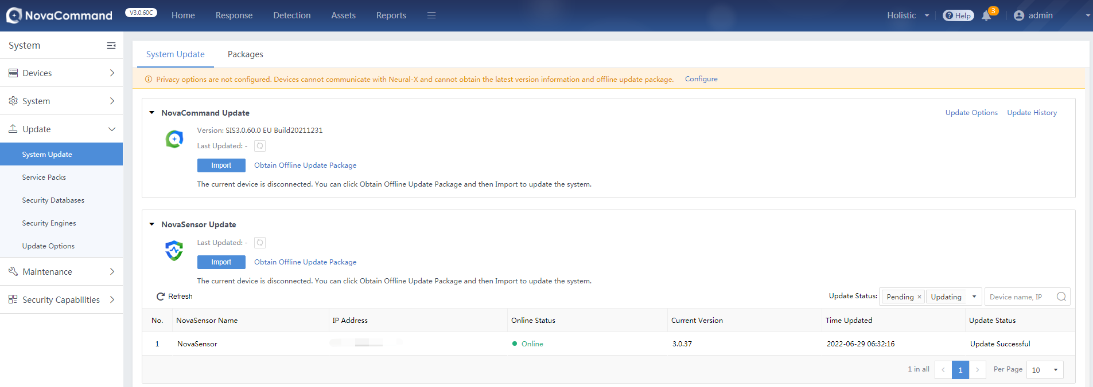
Step 2 Click Import to upload an update package.
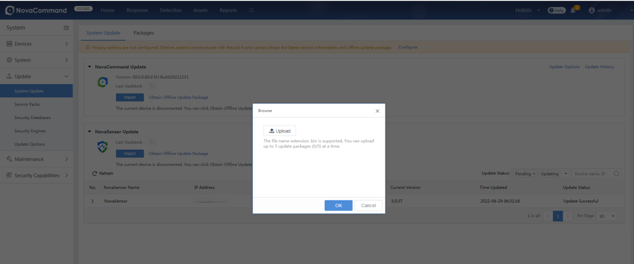
Step 3 Click Upload Package to upload the update package that has been downloaded to the local device.
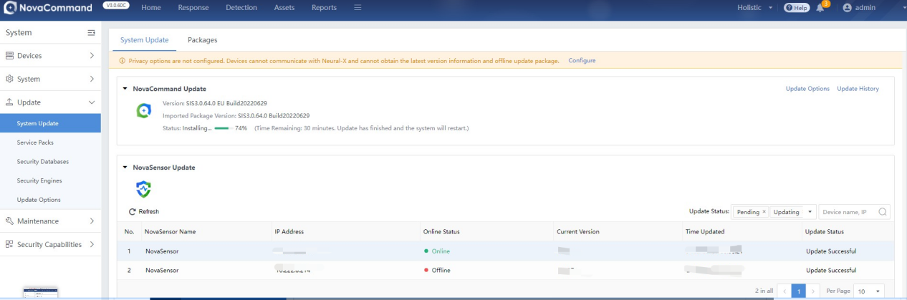
Do not close the uploading page while uploading the update package. Otherwise, you have to enter the page again and repeat the preceding steps.
Step 4 After the update package is uploaded, click Next to back up configurations, and then the upgrade will start. After the upgrade is complete, the device will restart automatically. Log in again to check the version and device status.

- Troubleshooting Upgrade Failures
- Scenario 1: Upgrade failed
Troubleshooting:
- Check whether .ssu package is complete and verify MD5.
- Check whether upgrade is supported for the version.
- Check whether the upgrade license is valid.
- Log in to the backend to check whether there are error messages or anomalies from /var/log/ssu_update.log. If yes, contact the technical support.
- Scenario 2: Stay on the update page for long time
- Troubleshooting:
- Refresh the page to see whether you will go to the login page.
- Log in to the background to check whether the console version has been upgraded to NC3.0.64C and whether there are error messages or anomalies from /var/log/ssu_update.log. If yes, contact the technical support.

- Scenario 3: Login verification code cannot be displayed after being refreshed
Troubleshooting:
- The mongo database is not started. In this case, wait for the mongo database to be started.
- Log in to the background to check whether the console version has been upgraded to NC3.0.64C and whether there are error messages or anomalies from /var/log/ssu_update.log. If yes, contact the technical support.

- Scenario 4: Network error occurs after login to console
Troubleshooting:
- Errors occur on pages of the console when Elasticsearch database is not started. In this case, wait for the Elasticsearch database to be started.
- Log in to the background to check whether the console version has been upgraded to NC3.0.64C and whether there are error messages or anomalies from /var/log/ssu_update.log. If yes, contact the technical support.
- Rollback Instructions
Rollback is not supported. If any issues occur after the upgrade, please contact the technical support for help.

