NovaCommand 3.0.64

Release Notes



Drafted By | Cao Wei  Wang Xinsheng | Date | 2022-06-30
Reviewed By |  | Date

Content
NovaCommand 3.0.64 1
Release Notes 1
1. Version Benefits 3
2. Version 4
3. Version Features 5
4. Feature Details 6
4.1 Alerts Displayed by Details or Correlation 6
4.2 Alert/Incident Proof Optimized 7
4.3 Custom Intelligence 10
4.4 Whitelist Optimization 11
4.5 Cluster Expansion 15
4.6 Netherlands Available for Customer Location 16
4.7 Licensing Management of Third-party Integrated Devices 17
4.8 Threshold Settings for the Abnormal Behavior Engine 19
4.9 Audio Alert 21
4.10 New Connection Method Between NovaSensor and NovaCommand 22
4.11 Access Control for Source IP Addresses 25
Issues Fixed 26
Software List 27
Contact Us 27

Version Benefits
This version allows you to view the page about alert details, customize security events, expand clusters, integrate HCI, and configure thresholds for the abnormal behavior engine. It also optimizes the alert/incident proof and whitelists. Besides, some issues have been fixed. The architecture is optimized, response is faster, and the user experience is enhanced.

Version
Version | NovaCommand 3.0.64
Released On | June 30, 2022
Project Owner | Cao Wei
Reviewed By
Release Notes | See section 3

Version Features
No. | Description
1 | Enhanced: Alerts displayed by details or correlation
2 | Enhanced: Alert/Incident proof optimized
3 | New: Custom intelligence
4 | Enhanced: Whitelist
5 | New: Cluster expansion
6 | New: Netherlands can be selected as a customer location which also applies to the monitor
7 | New: Licensing management of third-party integrated devices
8 | New: Threshold settings for the abnormal behavior engine
9 | New: Audio alert
10 | New: AKSK added to the connection method between NovaSensor and NovaCommand
11 | New: Access control for source IP addresses

Feature Details

4.1 Alerts Displayed by Details or Correlation

Benefits
Allow security engineers to better handle security alerts by displaying them by details or correlation. They can choose the display mode as required.

Scenarios
Security operation and maintenance

Target Users
Security admin, O&M personnel

UI
1. By Details
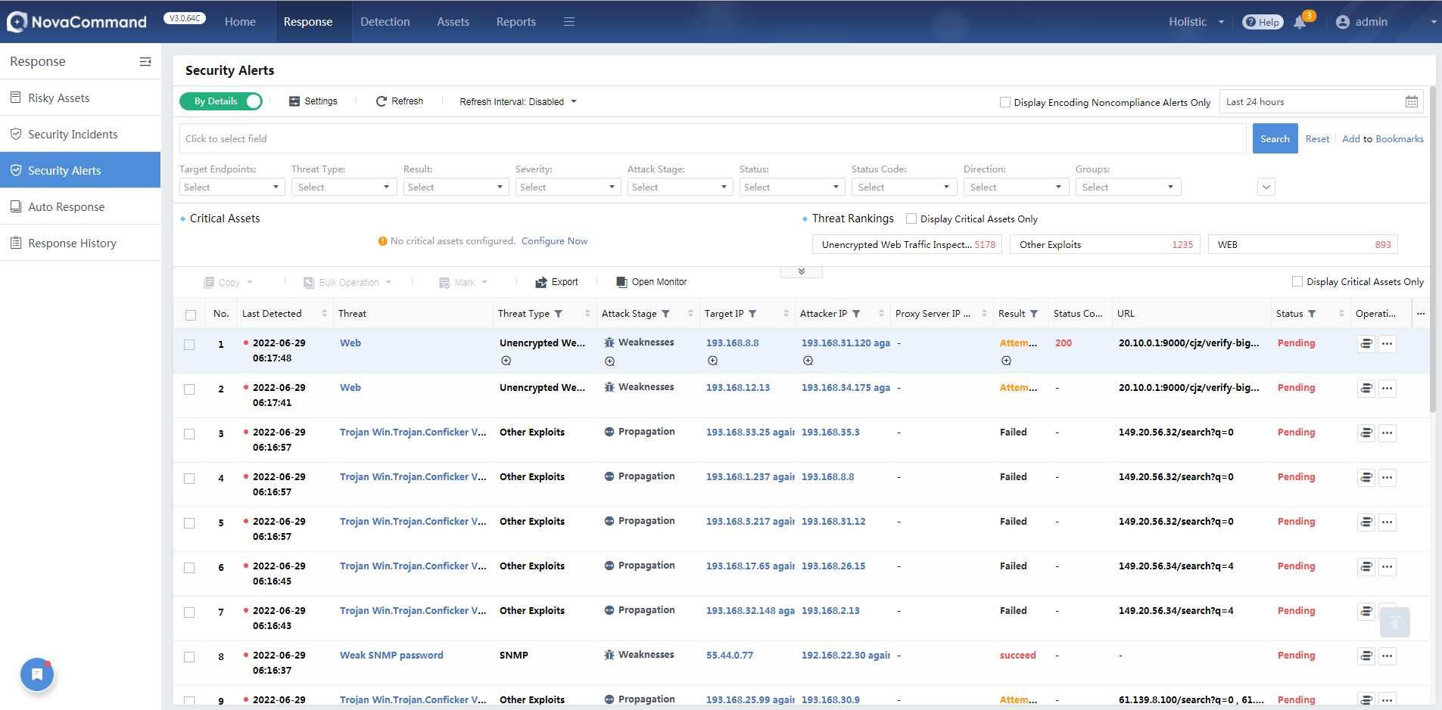

2. By Correlation
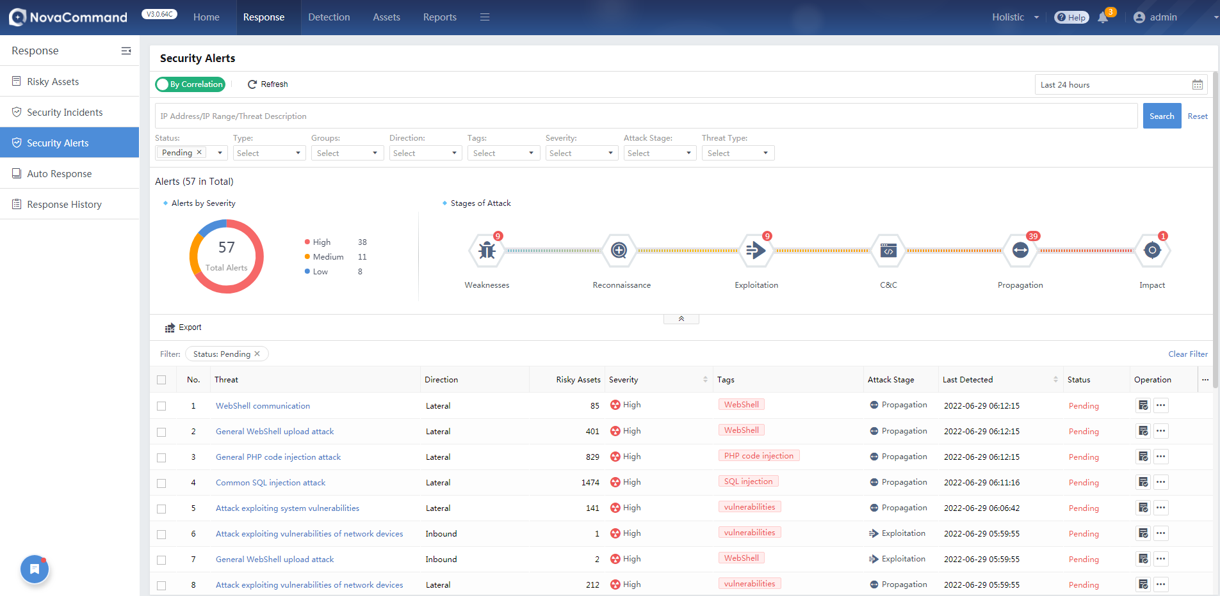

Pending Issues and Notes
None

Troubleshooting
None

4.2 Alert/Incident Proof Optimized

Benefits
Security engineer can quickly understand the logic of an alert or incident, and its relationship with logs.

Scenarios
Security operation and maintenance

Target Users
O&M personnel

UI
1. Allow to display threat information in a table not nested when multiple attackers are associated with multiple targets in Threats tab.
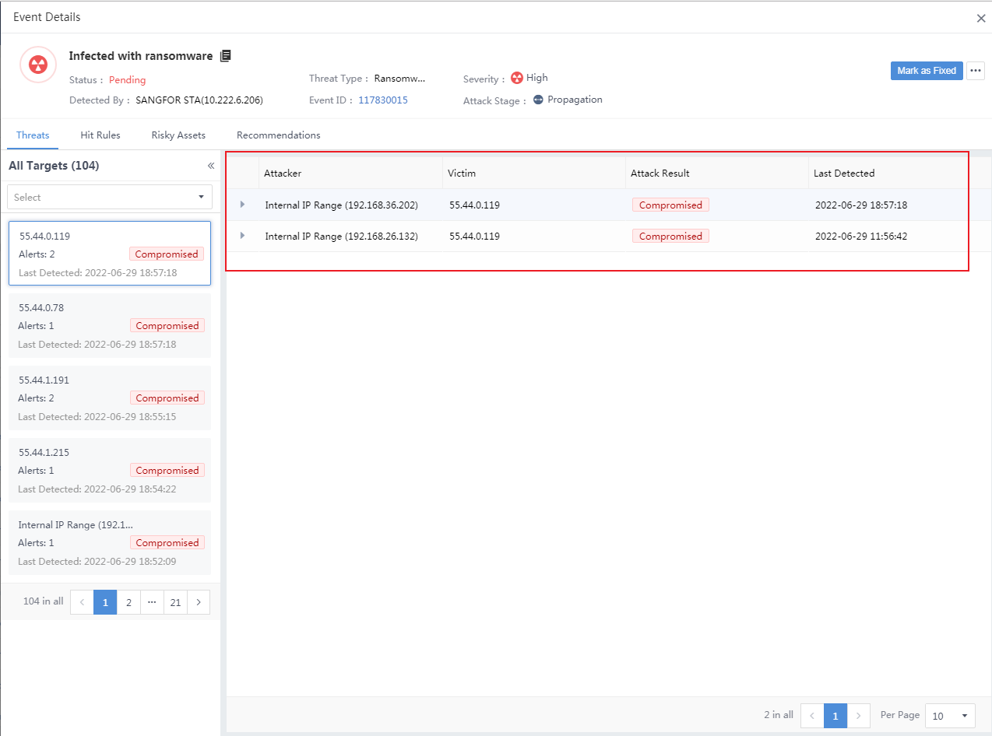

2. You can view the threat type as below.
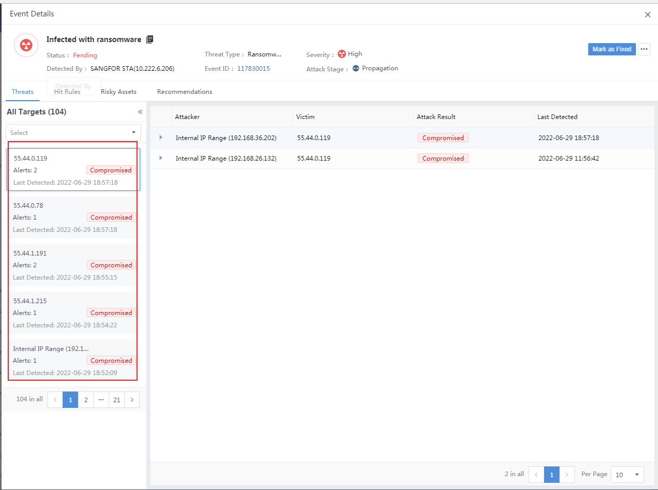
3. You can click Go to Logs to go to the Logs page.
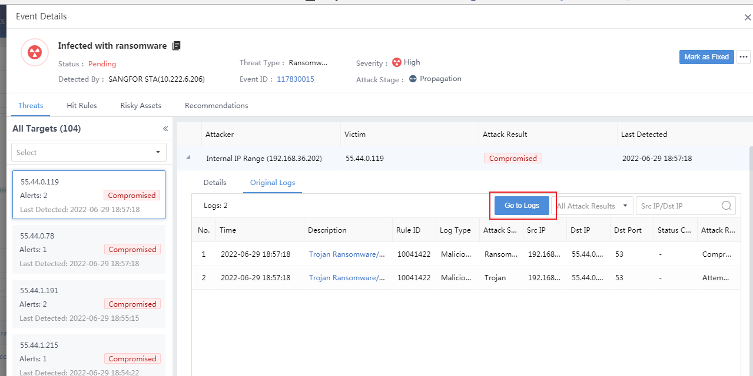
4. The styles are made consistent between the Log Details page and the Logs module.
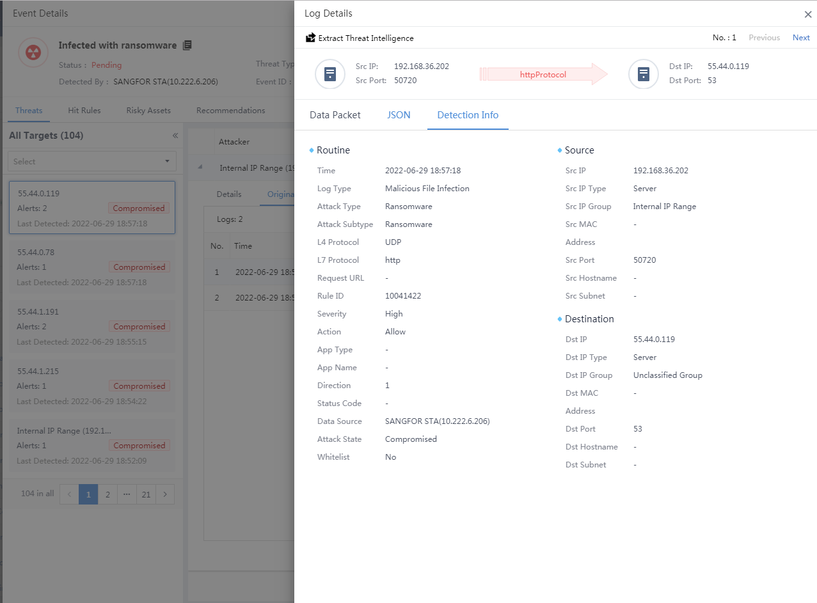

4.3 Custom Intelligence

Benefits
Security engineers can customize alarms/incidents as required, to improve detection accuracy and reduce operation and maintenance costs.

Scenarios
Security operation and maintenance

Target Users
O&M personnel

UI
1. System > Security Capabilities
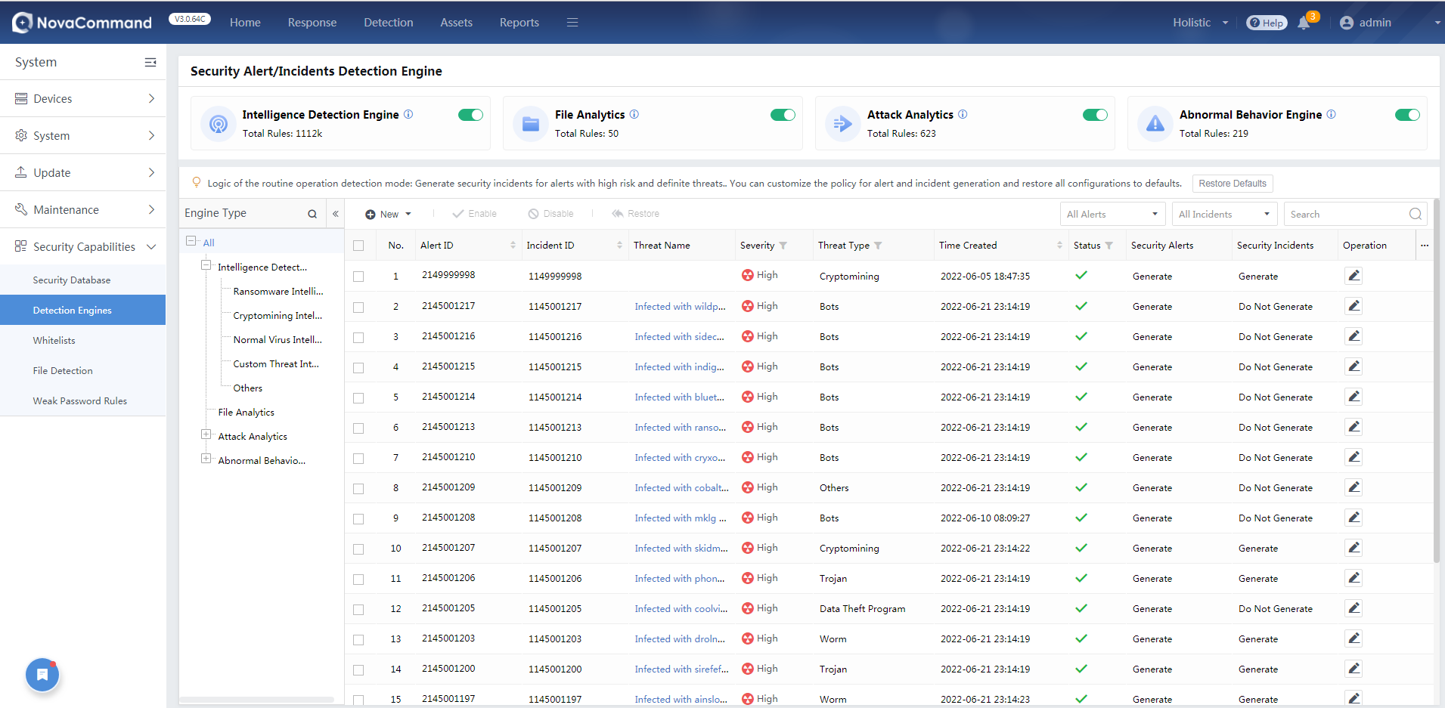

Pending Issues and Notes
None

Troubleshooting
None

4.4 Whitelist Optimization

Benefits
1. You can go to System > Security Capabilities > Whitelists to export and import security whitelists and audit whitelists.
2. Push down audit whitelists to NovaSensor, reducing the audit workload of NovaSensor.
3. Allow to select all whitelists and configure whitelists more flexibly. For example, you can whitelist a kind of email address suffix like "*@google.com".

Scenarios
Security administrators need to easily manage and configure security capabilities.

Target Users
Security admin, O&M personnel

UI
Go to System > Security Capabilities > Whitelists to export whitelists.
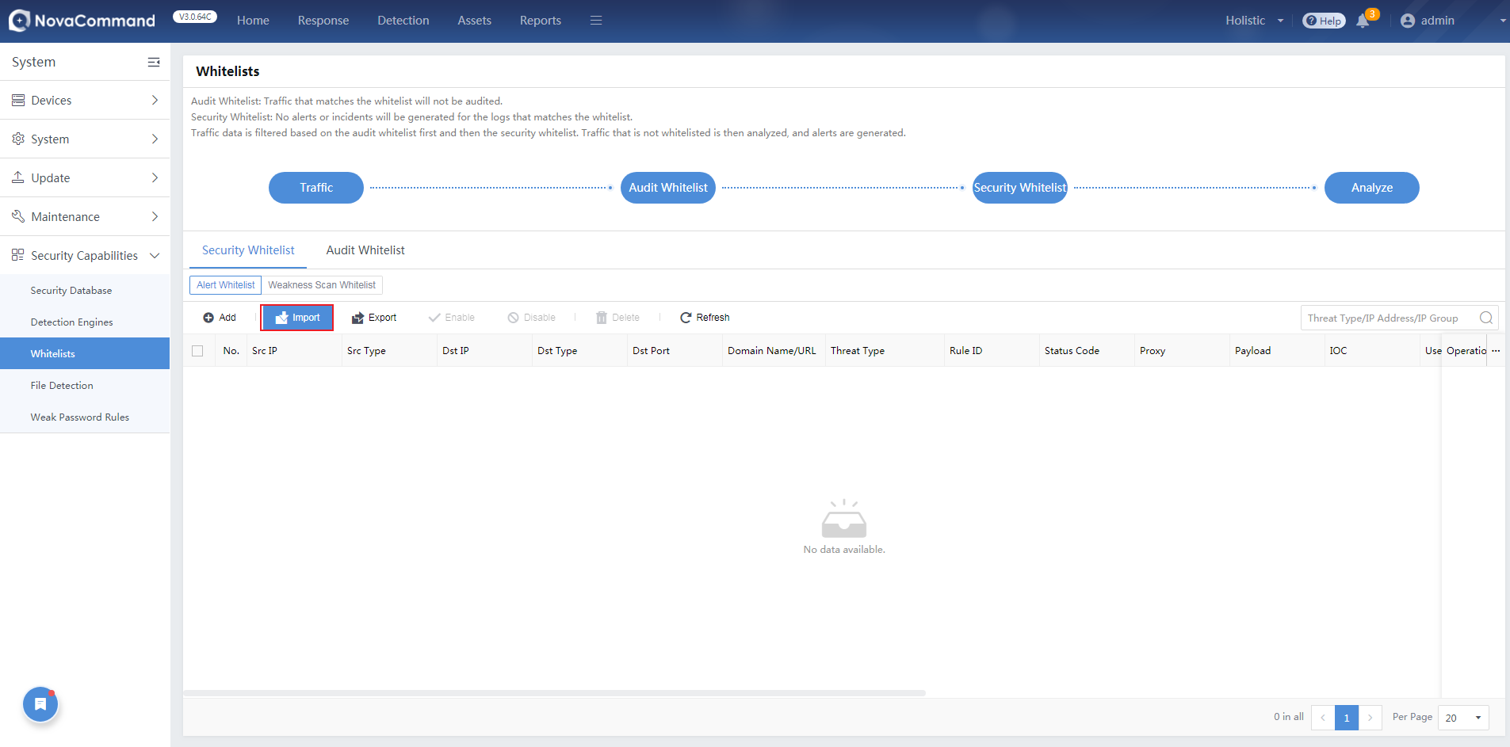

You can also import whitelists (.csv file).
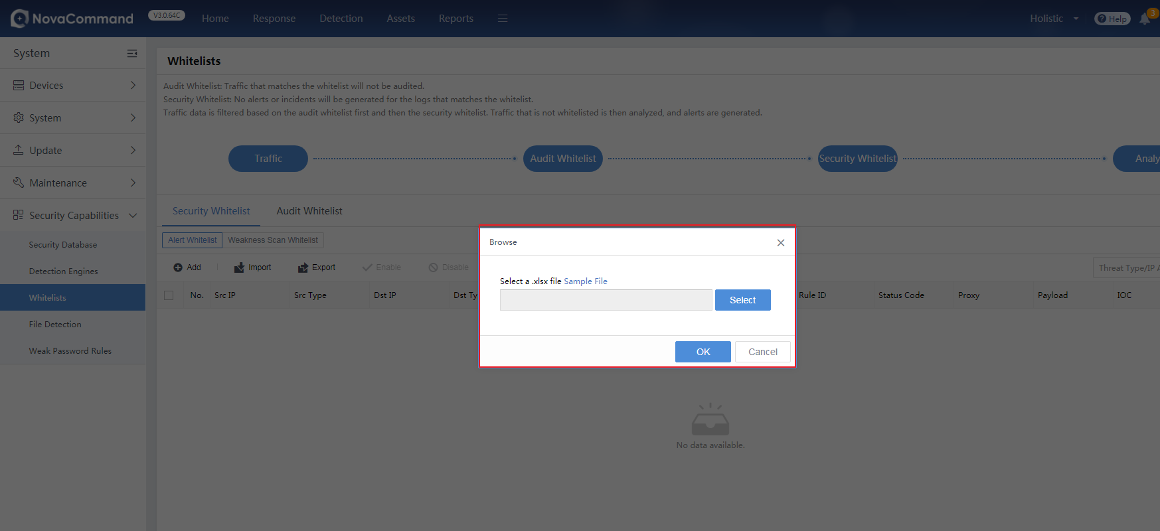

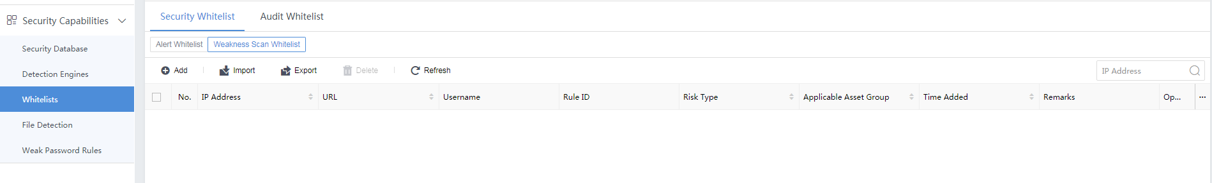
2. On the System > Security Capabilities > Whitelists page, you can configure audit whitelists which will be automatically synchronized to NovaSensor.
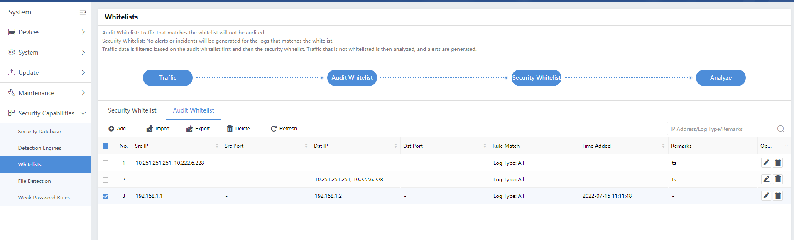

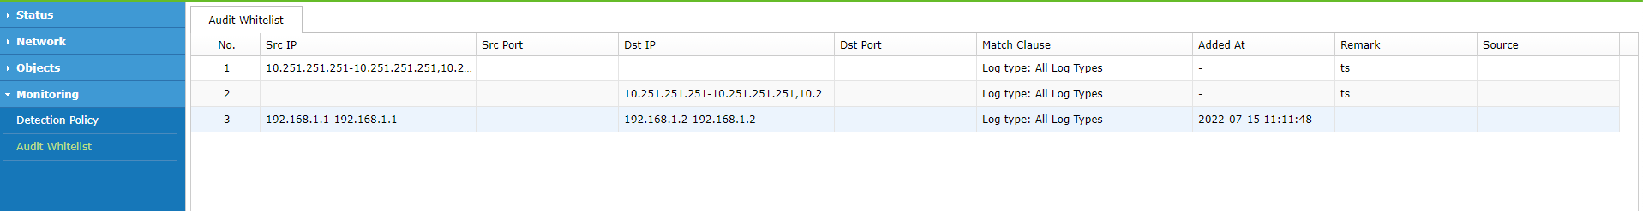
3. You can configure whitelists more flexibly on the following page.
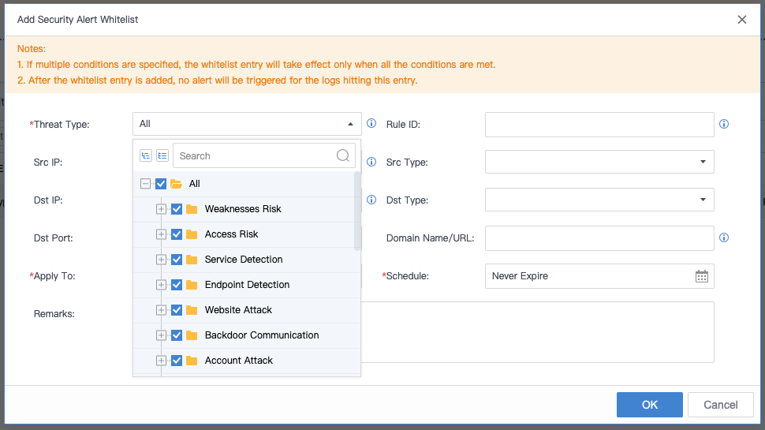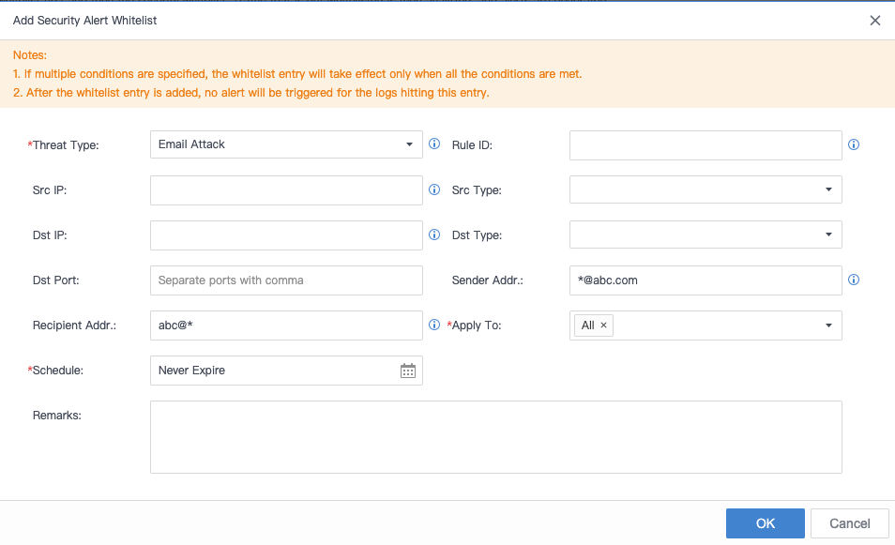

Pending Issues and Notes
None

Troubleshooting
None

4.5 Cluster Expansion

Benefits
The maximum traffic that the current platform can support is limited. If large traffic needs to be used, you can expand the capacity by adding cluster nodes.

Scenarios
The network traffic of a customer is too large to be supported by a single platform.

Target Users
Security admin, O&M personnel

UI
You can go to System > Devices > Clusters > Configure Cluster to add cluster nodes.
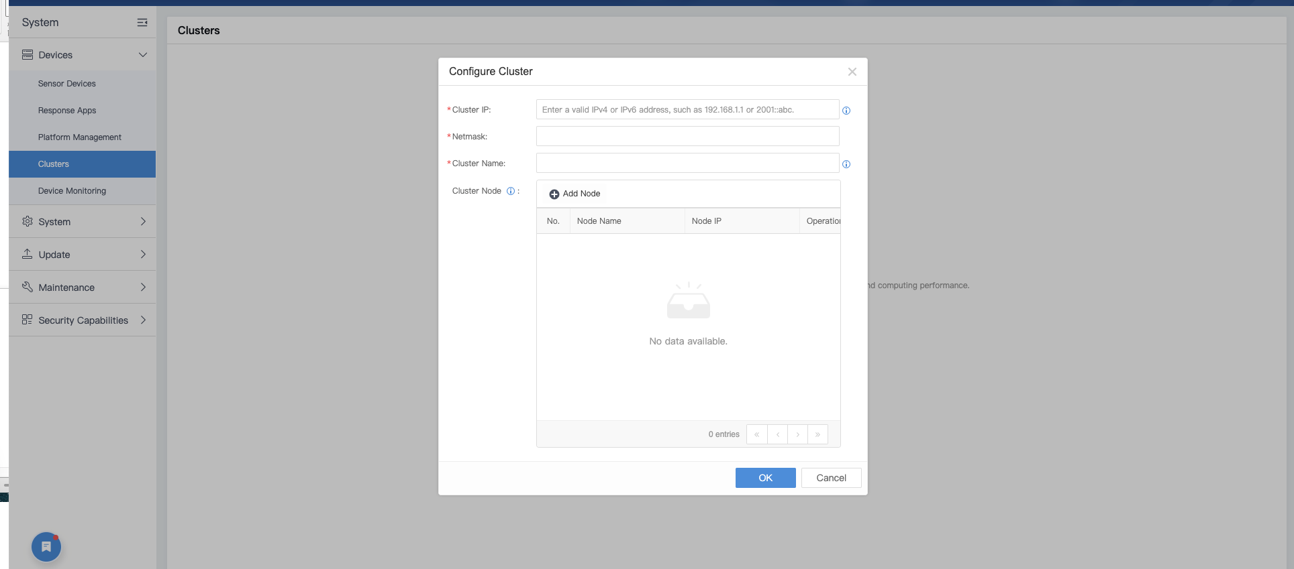

Pending Issues and Notes
1. When creating a cluster, ensure that the hardware specifications of each cluster node are the same, and the memory is greater than 96 GB
2. When a cluster is created, the overall performance of the cluster will be about 80% of total performance of all cluster nodes.
3. When you need to set up 3 or more clusters, please consult the R&D team first.

Troubleshooting
None

4.6 Netherlands Available for Customer Location

Benefits
Netherlands can be selected as the country where a customer locate, which will be automatically synchronized to the monitor.

Scenarios
Used for the Netherlands market

Target Users
Security admin, O&M personnel

UI
Go to System > System > General > Web UI > Service Control > Country/Region to select the country or region where the customer is located.
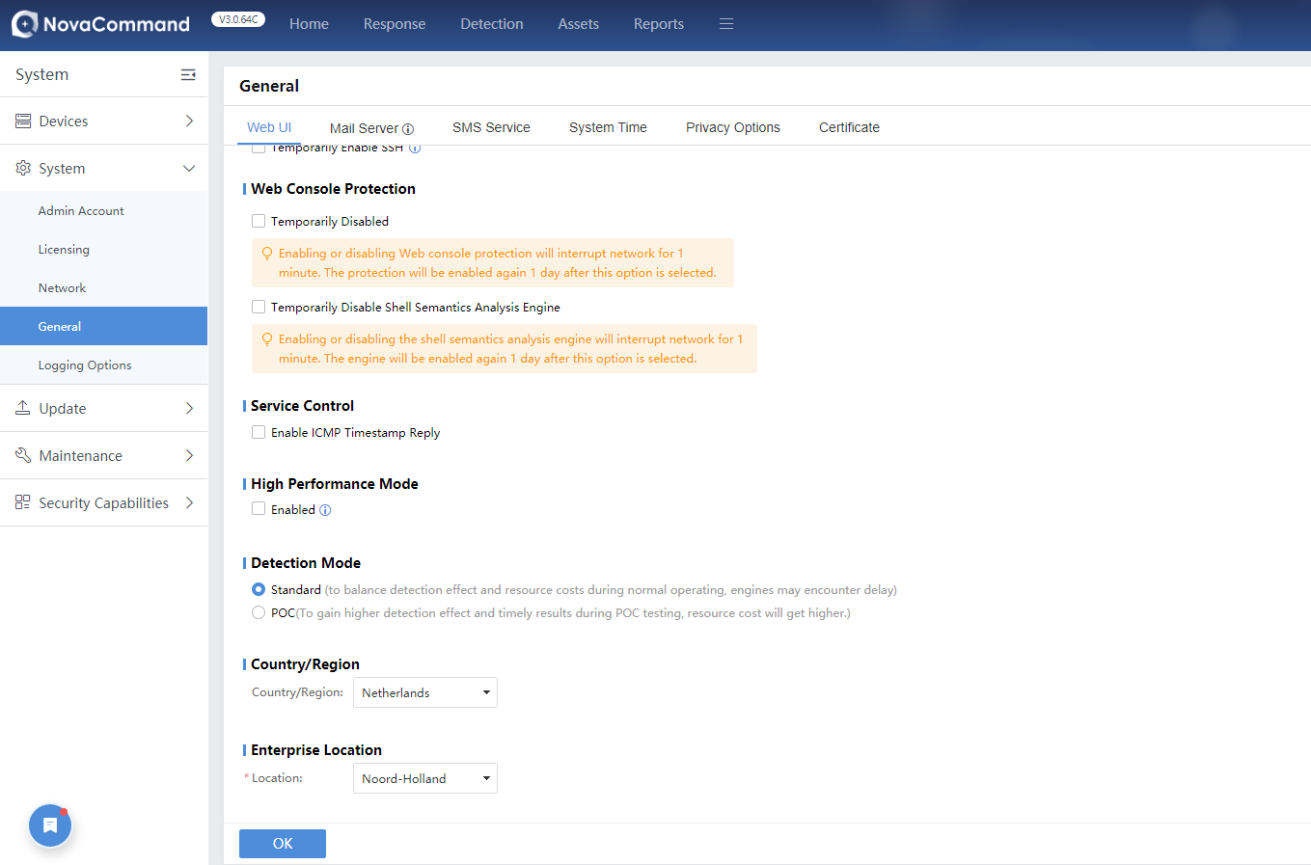

4.7 Licensing Management of Third-party Integrated Devices

Benefits
To better manage the third-party integrated devices used by customers, you can license those devices based on quantity and validity period now.

Scenarios
Security operation and maintenance, device integration

Target Users
Security admin, O&M personnel

UI
1. Go to System > System > Licensing to export device information and apply for licensing again. There is no limit to the number of integrated devices for a single app category.
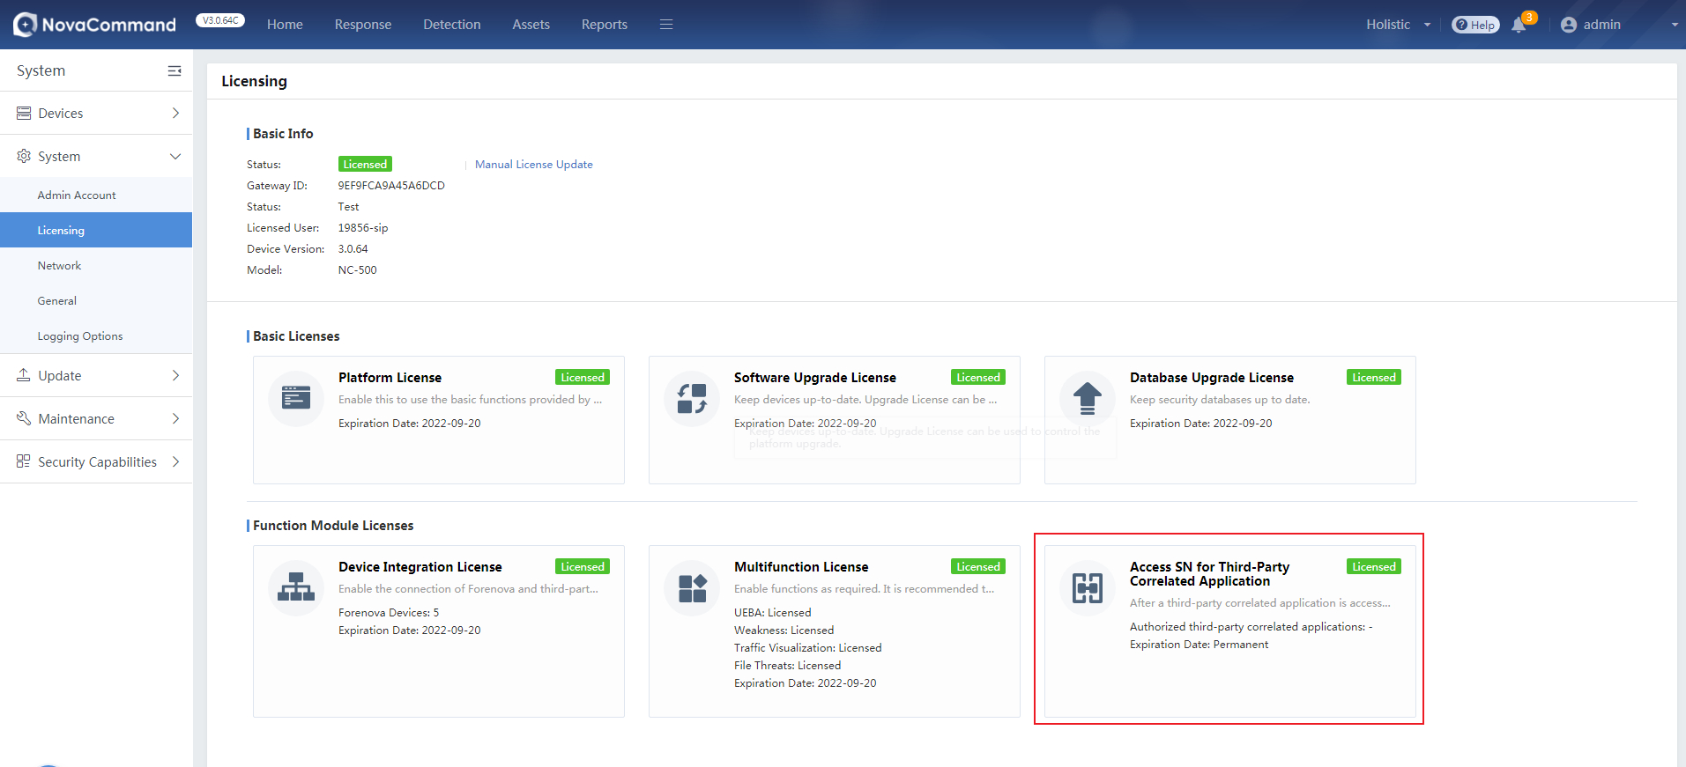

2. On the System > Devices > Response Apps page, third-party devices not licensed are displayed in gray, devices licensed but not integrated are displayed in orange, and devices licensed and integrated are displayed in green.
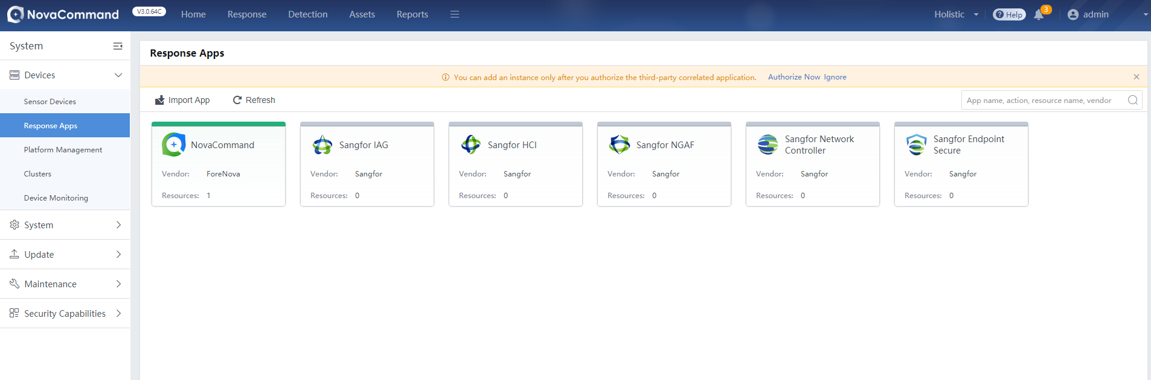

Pending Issues and Notes
If a third-party app, having been imported to previous NovaCommand versions, is not licensed immediately after the upgrade, the original third-party app will still be available, but you cannot edit or add its resources.

Troubleshooting
None

4.8 Threshold Settings for the Abnormal Behavior Engine

Benefits
You can configure thresholds for scans and brute-force attacks detected by the abnormal behavior engine.

Scenarios
Security operation and maintenance

Target Users
O&M personnel

UI
Go to System > Security Capabilities > Detection Engines > Abnormal Behavior Engine, and click a rule for configuration.

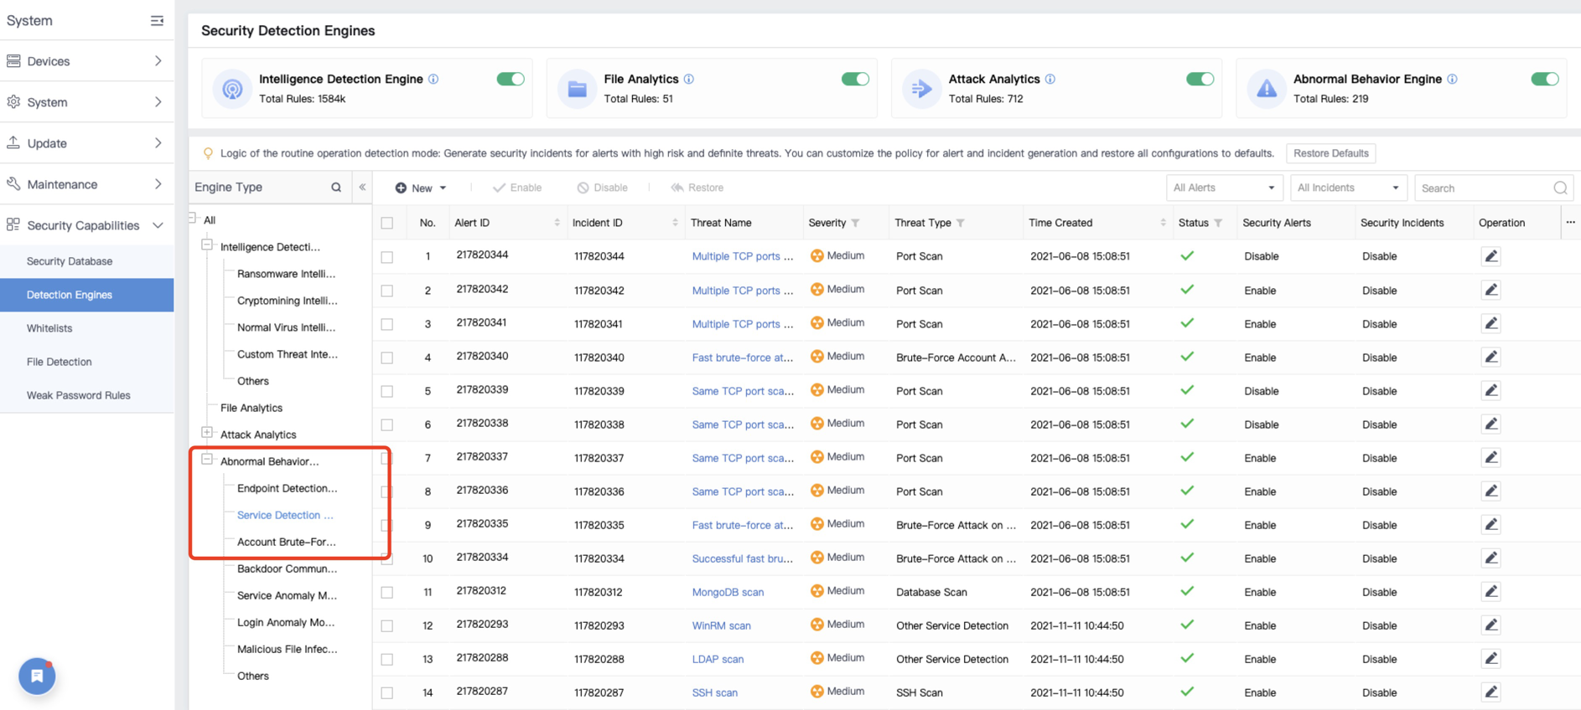

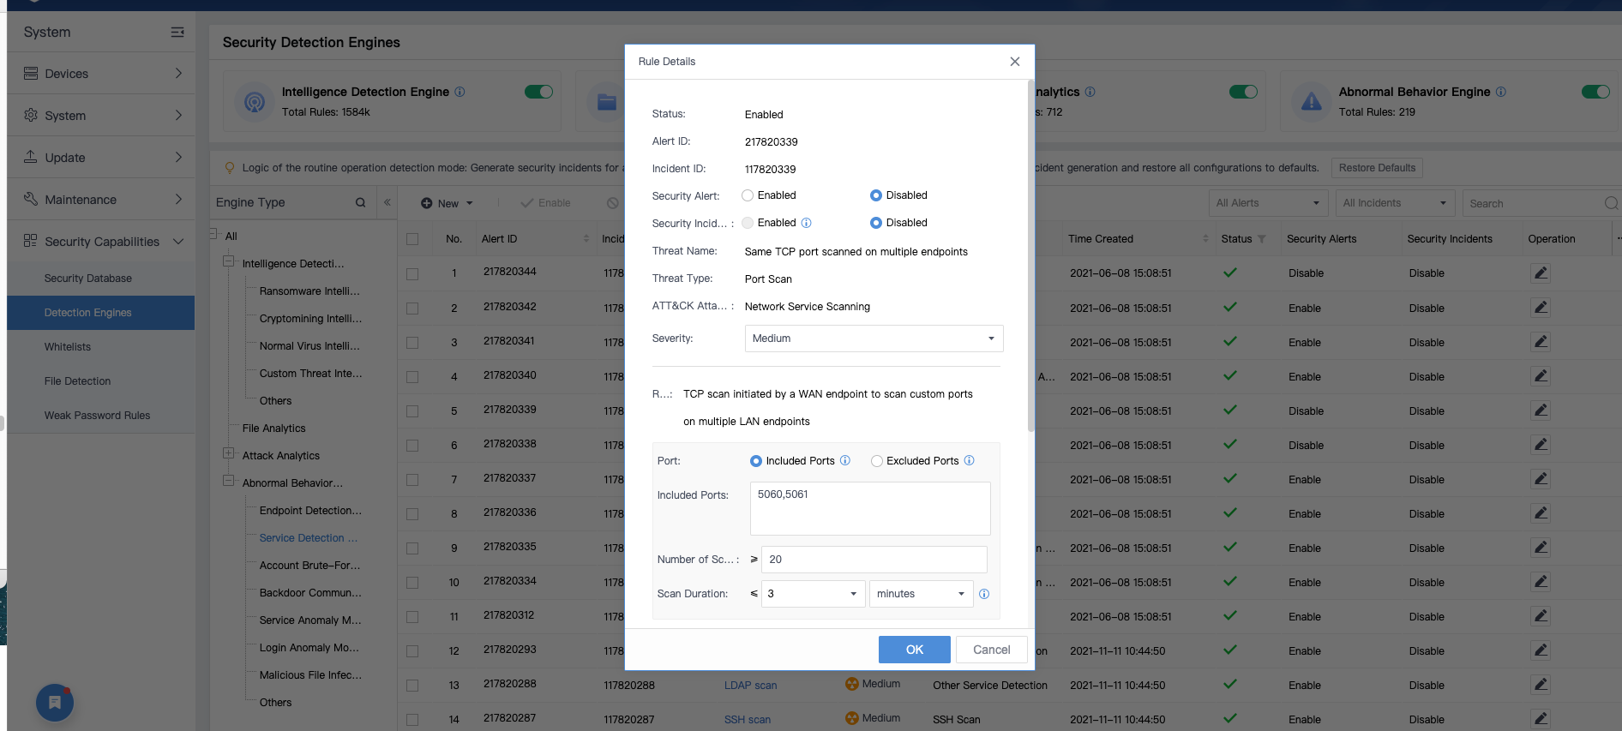

Pending Issues and Notes
You can only configure thresholds for rules related to scans and brute-force attacks.

Troubleshooting
None

4.9 Audio Alert

Benefits
Audio alert can be set to notify users of threats that they are concerned.

Scenarios
Security operation and maintenance

Target Users
Security admin, O&M personnel

UI
- Go to Response > Security Alerts, and click Settings to set conditions to trigger audio alerts.
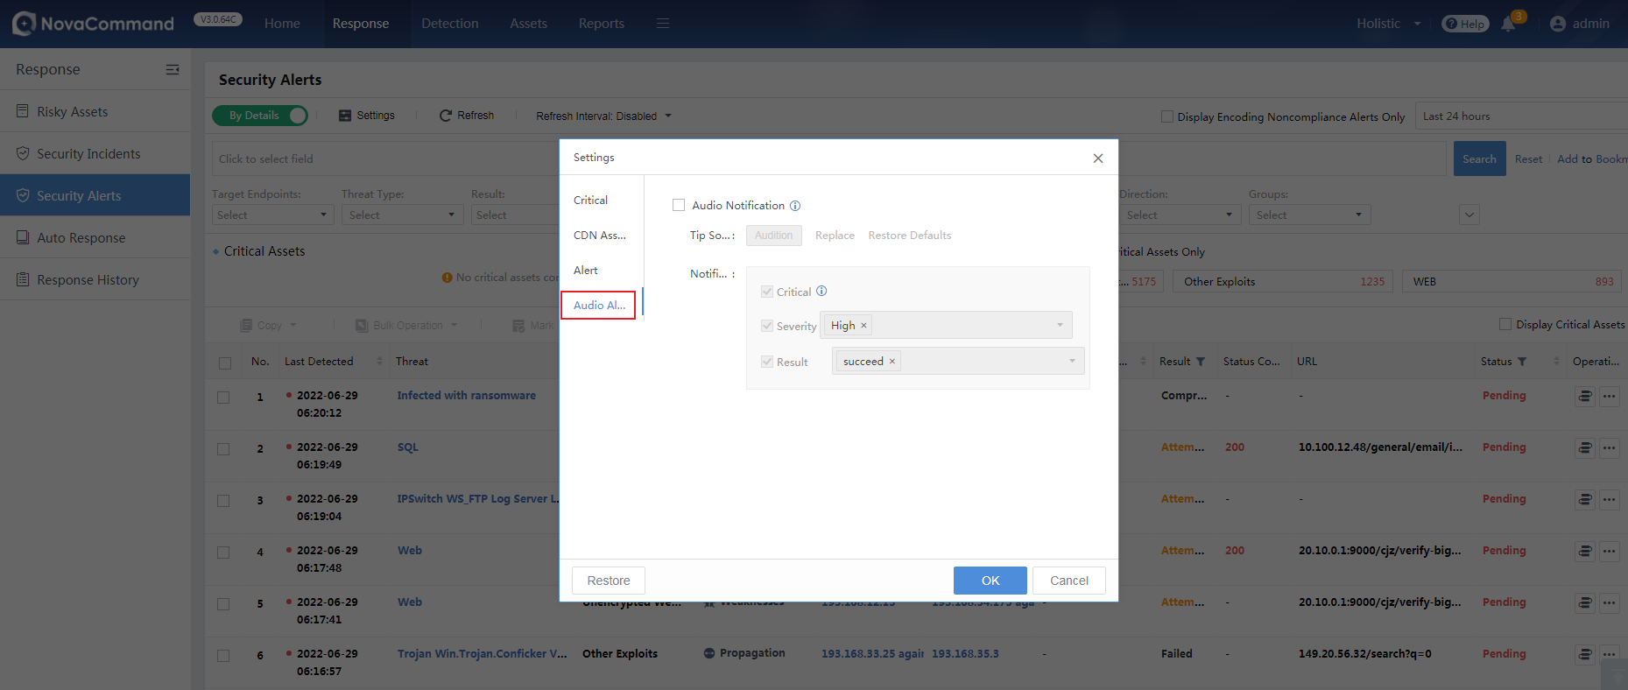

- When a successful attack of a threat level is detected, the PC will send an audio alert.
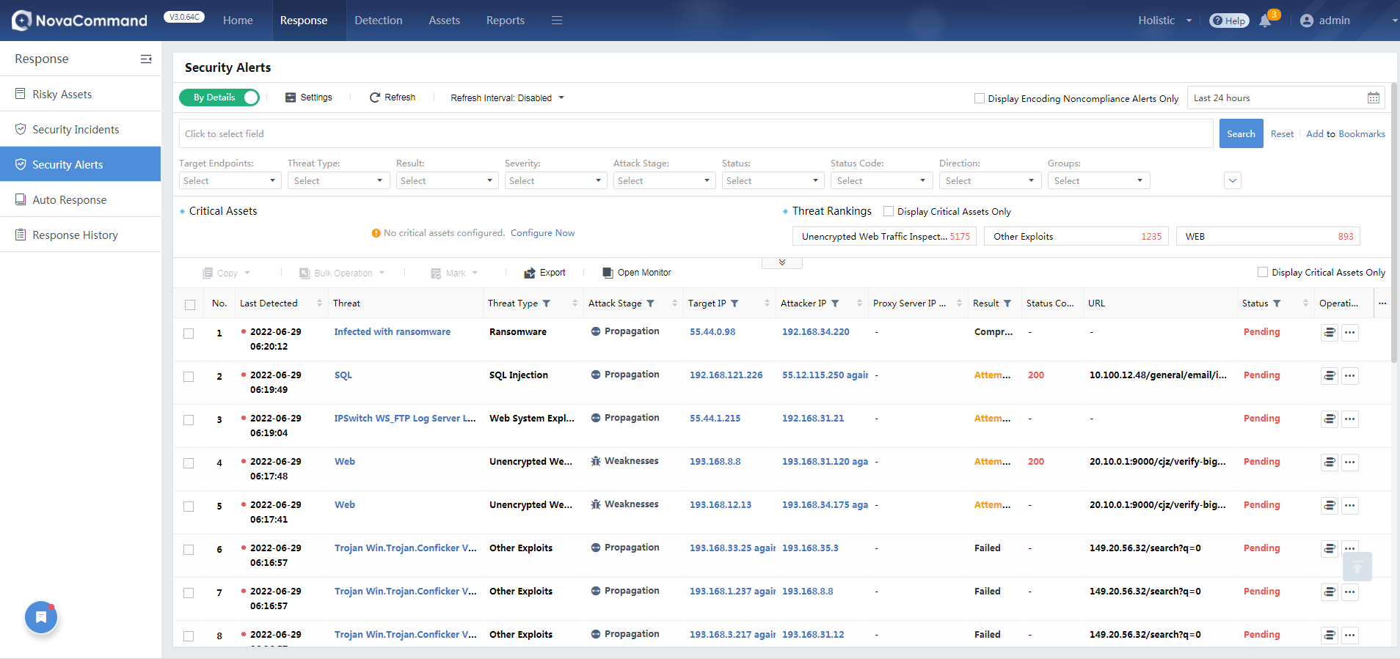

Pending Issues and Notes
Audio alerts will be available only when you constantly open a monitor to display the Security Alerts page or stay on the Security Alerts page.

Troubleshooting
None

4.10 New Connection Method Between NovaSensor and NovaCommand

Benefits
Optimize the connection method between NovaSensor and NovaCommand by using AKSK, to make their communication more secure.

Scenarios
Operation and maintenance

Target Users
O&M personnel

UI
1. On NovaCommand, go to System > Devices > Sensor Devices to click NS Connection Configuration to generate a connection key.

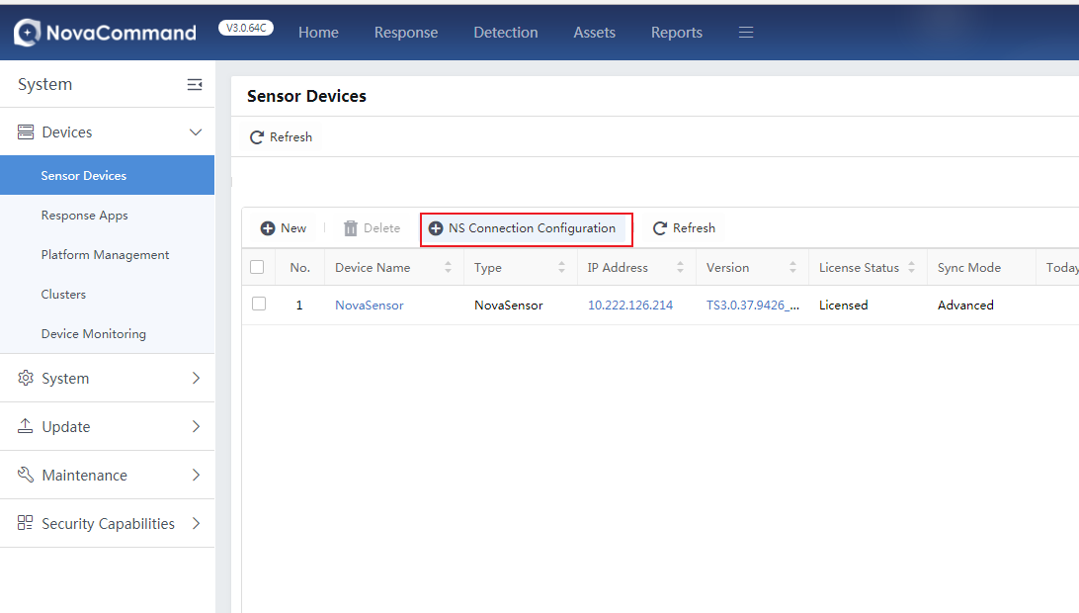
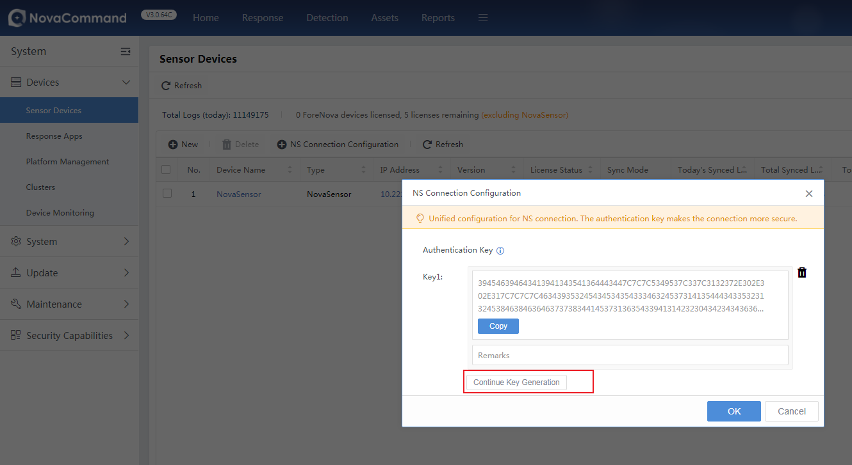

2. On NovaSensor, go to System > NovaCommand to enter the IP address and authentication key of NovaCommand.
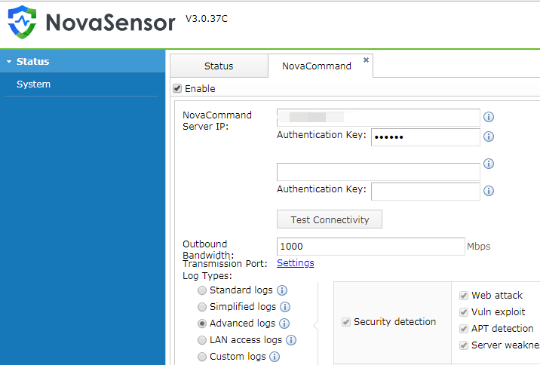

Pending Issues and Notes
- Multiple NovaSensor devices can use the same key or different keys.
- Only NovaSensor 3.0.37C or later can be connected to the platform using AKSK.
- For NovaSensor devices that have been connected to a version earlier than NovaCommand3.0.60, choose the connection method previously used for graceful upgrade.

Troubleshooting
None

4.11 Access Control for Source IP Addresses

Benefits
You can set the IP addresses that are allowed to access the platform backend.

Scenarios
Operation and maintenance

Target Users
O&M personnel

UI
Go to System > System > General > Web UI > Remote Control to enable source IP access control, and specify the allowed addresses.
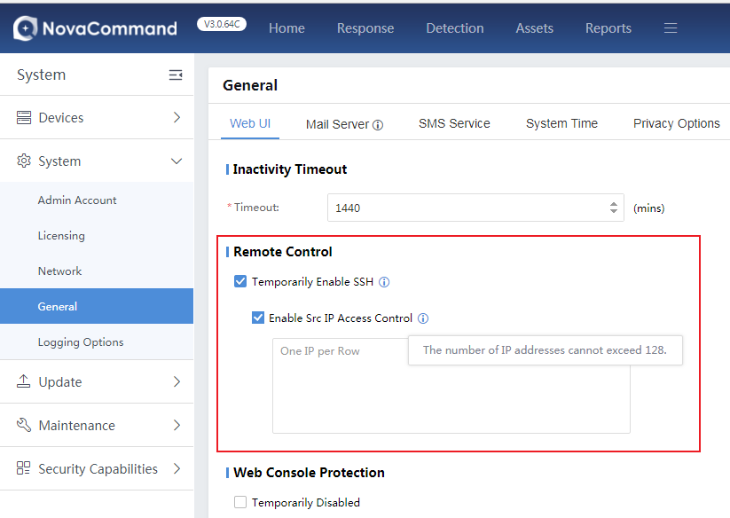

Pending Issues and Notes
The number of IP addresses cannot exceed 128.

Troubleshooting
None

Issues Fixed
Developed based on version 3.0.64, this version has inherited the issues of previous versions.

Software List
Items | File | MD5
Software Installation Package | NovaCommand3.0.64C(20220630).bin | 80F12EB476EE7B3427E1117C0BC5D194
Database Upgrade Package
Upgrade & Delivery Guide
Compatibility List

Contact Us
Email: support@forenova.com
Official Website: www.forenova.com

